|In this Issue:

* Invitation to the

19th IROICA

Annual Conference

* IROICA 2014 - 2016
* Call to action
* Membership in IROICA vzw
* ICA events
* IAAS activities

# |Invitation to the 19th IROICA Annual Conference

We are very pleased to invite you to the 19th IROICA Annual Conference entitled **“International Alumni Networks”**  that will be hosted this year by the **University of Agriculture and Veterinary Medicine, Cluj-Napoca.** The conference also focuses on the Erasmus+ Programme and updates concerning other EU Programmes. Two vocational training will be included in the programme as well.

Detail logistical information and detail programme will be available soon. The conference will take place from **June 8 to 11, 2015**. **Please save the date!**

We are looking forward to seeing you !

IROICA Executive Committee & Conference Organizers

# |IROICA 2014  2016

During the last years the IROICA and its Executive Committee (ExCo) worked hard on the following issues (among others):

▪  professionalizing our communication- with a new logo, use of social media,…

▪  getting legal statutes - with the registration of our official statutes ▪  linking to ICA

In order to cope with this rapidly changing environment, IROICA needs to rely on an adapted strategy based on the needs of its members. Therefore, the members of the ExCo would like to use their mandate during the next two years to:

▪  continue in professionalizing our communication,

▪  consolidate our statutes with involvement in different, new (EU) projects,

▪  elaborate on the linkages between IROICA and ICA and the other standing committees as well as IAAS,

▪  professionalize our data management,

▪  focus on an interesting offer of vocational training for our members.

# |Call to action

All IROICA members that would like to be more actively involved in any of these activities; please let us know! Would you like to make some contributions to our social media channels, reflect on possible links with IAAS, become a member of the project team, or any other (wild) idea… your contributions will be appreciated!

**Get involved in the IROICA team and participate in our activities!**

# |Membership in IROICA vzw

**IROICA vzw** is the European network of international relations officers working at

Life Sciences Universities and Faculties. IROICA is a network of individual members - membership is not on institutional basis and it is **free of charge.** Thereby a very wide pool of expertise is created, at the Annual Conference and workshops members can share and benefit from all different kinds of experiences.

**Our activities include: | Annual Conference | Workshops | Projects |**

WOULD YOU LIKE TO JOIN US? | [IROICA membership application form](http://goo.gl/forms/ePobAjmXsu) CONTACT US! | <http://www.ica-iroica.eu/> | [Like us on Facebook!](https://www.facebook.com/pages/IROICA/308747647547?fref=ts)

# |ICA events

[**ICA-Edu colloquium**](http://www.ica-ls.com/index.php?option=com_content&view=article&id=201:ica-edu-colloquium-2015&catid=33:upcoming-conference&Itemid=225) **“Educating Life Science Graduates Fit for Europe”**, 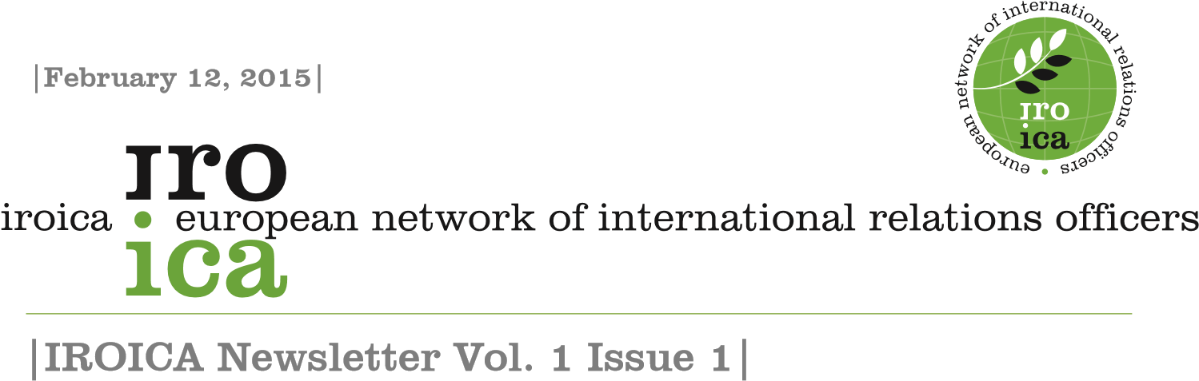

15 – 16 April 2015, to be held at University of Natural Resources and Life Sciences, Vienna, Austria (BOKU).

[**6th CASEE Conference**](http://www.casee2015.uniag.sk/) **“Latest trends in Bioeconomy in the Danube Region”**,

1. – 26 May 2015, to be held at Slovak University of Agriculture in Nitra, Slovakia.

[**CIHEAM - ICA Zaragoza Conference**](http://www.ciheam.org/index.php/en) **“Agricultural Higher Education in the 21st C: global challenge in knowledge transfer to meet world demands for food security and sustainability”**, 15 – 17 June 2015, to be held at CIHEAM Zaragoza,

Spain. This conference is sponsored by the OECD Cooperative Research Programme. Details to follow.

[**GCHERA 8th World Conference Universities**](http://webapp.usek.edu.lb/forms/WS/gchera/index.html) **“Global Challenges: nutritional security and environmental sustainability for human health”**,

1. – 26 June 2015, to be held at Faculty of Agricultural and Food Sciences, Holy Spirit University of Kaslik, Lebanon.

[**AgriMBA International Congress**](http://www.agrimba-ava2015.hr/kontakt-2/) **“Smart Agribusiness for the Society of Tomorrow”**,16 – 20 June 2015, to be held in Poreč, Croatia.

More information available at: <http://www.ica-europe.info/>

# |IAAS activities

**World Congress in Iowa, USA**

The Annual World Congress of IAAS was this year organized at the Iowa State University, USA, with the theme: Farming for the Future.

The IAAS General Assembly was first held to discuss about our Association’s future. Next, students from all over the world could experience both small-scale organic as large conventional farms and a special visit to a agricultural machinery factory was included.

**ExCo Meeting in Italy**

The coordinators of the IAAS Exchange Program met this year in Sassari, Italy, to maintain and improve the working of our exclusive internships for students on farms in our Member Countries.

**Seminar in Croatia**

IAAS members were invited to get to know about

“Mountainous Croatia–potential for sustainable agriculture and development” both in theory as in practice during the seminar organised by IAAS students at the University of Zagreb Faculty of Agriculture last October.

More information available at: <http://www.iaasworld.org/>

We invite you to send us information from the scope of international cooperation and we will publish it in the IROICA

Newsletter or on IROICA Facebook page. E-mail: iroica.vzw@gmail.com

IROICA vzw

Reg. no 508.557.340

Kasteelpark Arenberg 20,

BE 3001, Leuven Belgium